Referendum Concept Plan
2018

Introduction
The Daily Targum is the second oldest college newspaper in the nation and has served the Rutgers community since January 29th, 1869. Then-Rutgers President William Campbell had lectured on the original text of the Old Testament, including Aramaic paraphrases of the Hebrew Scriptures called Targums. The Aramaic word “Targum” means “interpretation”, a translation that inspired the forthcoming publication’s name. The Daily Targum gained financial and legal independence from Rutgers University in October 1980. Since then, the Targum has conducted referenda every three years in order to qualify for student funding. This is the fifteenth concept plan submitted by Targum Publishing Company, for consideration under Alternate Procedure I, by the University Senate and the Office of the President. This document will demonstrate to the University Senate and the President that the Targum’s program continues to enhance educational, cultural, and societal goals of Rutgers University.

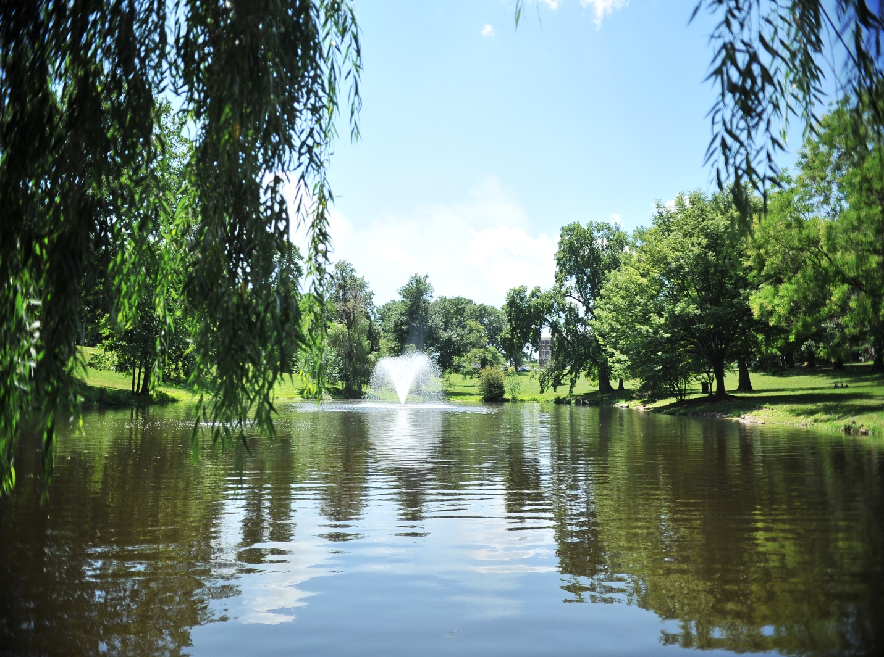

Mission Statement

The primary purposes of Targum Publishing Company are set forth in Article II of the company bylaws:
“To publish a newspaper and other related publications for the Rutgers Community… and to engage in activities serving the same community.”
“To enhance the educational and social goals of Rutgers University and to provide an education background in journalism related fields for the students of Rutgers University.”
The Daily Targum aims to serve as the flagship news source for local readers and focuses on Rutgers University, its students, college life, higher education, and the surrounding communities. The Targum provides readers with student perspectives on news directly affecting the Rutgers community as well as issues facing the nation and world as a whole. The newspaper, website, and social media applications published, updated, and maintained by the Targum provide students with a constant informational resource. What makes the Targum unique is that readers are able to truly identify with the paper’s content. The newspaper draws attention to the accomplishments, dedication, and passion of Rutgers students, providing a space in which they can be recognized and have their voices heard.
The Targum stays abreast of students’ opinions of the paper through a variety of channels. Person-to-person feedback, letters, Targum outreach to student groups, readership studies and open houses allow us to gauge the position of the Targum amongst the student body. Rutgers students demonstrate their eagerness for their voices to be heard through letters to the editor, online comments, and social network interactions. The newspaper truly creates a forum empowered to share their opinions on a variety of issues including university policy, cultural affairs, world politics, entertainment, and sports.
Students who are interested in the fields of journalism, publishing and business are actively invited and welcomed to participate in the operation of Targum Publishing Company and the production of the newspaper. The Targum provides a learning environment for students with a relaxed atmosphere but serious expectations. Targum alumni leave Rutgers with both skills that can be applied to their specific profession and lessons that can be used throughout their adult lives.

The Daily Targum truly provides a service to Rutgers University in pursuing our twofold mission. Our publication promotes awareness in the Rutgers community by simultaneously educating and entertaining. Open communication between the student body and the Targum has led to the creation of a forum that allows for debate and critique. Whether students work as reporters, photographers, managers, or in advertising sales they are certain to gain a truly unique professional learning experience.

Company Structure

Board of Trustees
The Targum Publishing Company Board of Trustees oversees all operations and directs the long-range financial planning of Targum Publishing Company. The company’s bylaws describe the structure and responsibilities of the Board.
The Board of Trustees meetings take place no less than two times per semester, and special meetings may be called at any time to take place at a time or location decided by the collective members of the board that are involved.
Voting members of the Board are selected by formal recommendations by current members who recognize the potential candidates capable of performing board duties either though past, or current service to the company. The eight voting student members of the board are chosen either through an interview or caucus process, and final approval by the Board of the candidate in question.
Board members are meant to serve as the final authority on matter which comes to their attention. Examples of this may include special personnel issues, final budget approval, and advice on various matters of day to day business operations. Board members provide personal, professional experience as a means of suggesting a given course of action.
Targum Publishing Company’s Board of Trustees consists of the four students managers; the Editor-in-Chief, Managing Editor, Business Manager, and Marketing Director. Selected students who are not involved in the direct publication of The Daily Targum fill the remaining student positions. These student trustees are nominated based on their involvement in the Rutgers community and their ability to offer a varied perspective on the paper’s reputation amongst the student body. Non-student positions include a University faculty member, Rutgers alumni, and a non-voting representative from the University administration.
Editorial
There are approximately 50 employees on the editorial staff. Of these, about 35 students make up the editorial staff, contributing to the news, sports, special issues, photography, layout, editorial, graphics and Inside Beat departments. The Editorial Board is comprised of 15 student editors who control the editorial content of the Targum. These students meet daily to decide matters of editorial policy.
Business and Productions
The business/productions staff is comprised of 15 employees, 13 approximately of which are Rutgers students. Student positions in the Business Department include the Business Manager, Marketing Director, Account Executives, Classified Manager, and Production Assistant. Targum Publishing Company employs a small professional staff to oversee the Accounting and Production Departments.
General Policies
Targum Publishing Company’s policy manual concretely, explains its standards for news articles, editorials, photography, online content, job descriptions and advertising. These policies resemble the ethical guidelines of professional organizations such as the Society for Professional Journalists, The Associated Collegiate Press and the American Society of Newspaper Editors. The policy manual is a living document created by the student executives. It was made to align The Daily Targum’s policies with other independent collegiate daily newspapers such as UCLA’s Daily Bruin, but also with regional daily papers such as The Star-Ledger and media organizations such as the Associated Press.
Educational Value
Targum Publishing Company
A Learning Environment
The Targum Publishing Company is a learning environment that welcomes and encourages all students to participate. Students who are involved in the editorial department gain invaluable experience from their involvement in each step of the publication of the newspaper. Reporters and editors learn important journalistic skills such as working under deadlines, conducting on-site interviews, building source relationships, and coping with high-pressure breaking news scenarios in the newsroom. Reporters on the news desk learn how to research a topic for a specific piece and prepare the proper questions in order to put together a complete article.
Targum editors introduce and address a wide range of issues in the newspaper. University life and culture, curriculum development, university funding, the state government, minority relations, and governmental affairs are a small sample of the topics covered in The Daily Targum. Editors hold training workshops for writers throughout the semester that aim to improve the editing abilities and writing quality of the Targum’s student writers.
Students involved in the design of the paper learn the proper techniques that contribute to a newspaper’s page layout, pagination, captions and headlines. The Daily Targum Graphic Designer will leave the job with comprehensive knowledge of a number of computer programs including Adobe Illustrator, Photoshop and Quark XPress.
The Multimedia features on www.dailytargum.com expose members of the editorial staff to digital media and the technology involved in modern journalism. Students have the opportunity to use new technologies to shoot and edit videos as well as create and edit audio slideshows. This increases accessibility and availability of the newspapers content for students, faculty, parents, and alumni.
Targum Publishing Company offers a wide range of opportunities for students to learn the business side of newspaper publication. The students employed in the business office of the Targum experience the publishing business firsthand and gain skills that can be applied in any professional situation.
The Business Manager acts as the co-CEO of the Targum, overseeing all operations. He/She manages the company’s budget, negotiates and signs contracts for the printing and delivery of the newspaper, and manages all employees involved on the business side. Because The Daily Targum is separate from the University, the student in this position is given the unique opportunity to oversee the operations of a company completely and make vital business decisions independently.
The Marketing Director is responsible for the advertising revenue of the company. He/She hires and manages a staff of Account Executives, establishes advertising rates for the year, manages the classifieds desk, and creates sales and promotional campaigns. It is the Marketing Director’s responsibility to establish and maintain relationships with national advertising agencies, local merchants, university organizations and departments, and all other clientele. This position provides the student with the unique opportunity to work with and manage their peers, while garnering hands on marketing and management experience.
Targum Publishing Company employs four to six Account Executives to work under the Marketing Director throughout the year. They sell advertising space in the paper to local businesses and University organizations. Account Executives learn how to negotiate contracts, make sales and pitch promotions, schedule and conduct meetings with customers, and advise in the layout of advertisements.
Community Asset
These positions give students an experience and education that can be gained only by hands-on practice and exposure. The hands-on exposure to sales and advertising gained from these positions gives these students the experience and education that can only be learned by practice and performance. These student Account Executives serve to create a link between the Rutgers Community and the local businesses in the area.
The editorial and business departments within Targum Publishing Company provide students with a distinct opportunity to apply the myriad concepts and skills they learn in the classroom to a formal business environment. Involvement with The Daily Targum allows for students with majors ranging from journalism to marketing to truly immerse themselves in the actual production and distribution of a newspaper and media company while exploring their interests and expanding their knowledge.
Publications
The Daily Targum is published approximately 138 times per year each day classes are in session with its size averaging 16-20 pages per day. 8,000 copies are produced and distributed daily throughout the New Brunswick/Piscataway campuses Monday through Friday. In recent years, as Rutgers has expanded, the geographical circulation of the paper has expanded with additional drop-off points in downtown New Brunswick and the four campuses of Rutgers.
The Daily Targum also produces a number of special issues throughout the year. The RU Connection is a summer magazine that is distributed to all incoming freshman and transfer students in order to familiarize them with the University and college lifestyle in general. Another project that The Daily Targum is responsible for is the First Year Student Care Package which is dropped off at every freshman dorm and the Off-Campus Student Association Office. Within the bag is a Rutgers School year event calendar, a coupon book to show students local hotspots, and various inserts from Rutgers associated departments and local businesses so students can familiarize themselves with the area that Rutgers covers. Furthermore, 2015 marks the first year for The Daily Targum’s Best of New Brunswick magazine that encapsulates a school wide vote by students for their favorite locations on campus and in the surrounding neighborhoods. The Cap and Gown issue is a commemorative issue to honor the graduating class each year. It features personals submitted by family members of graduates and pieces in which Targum writers reflect on their Rutgers experience.
The Daily Targum has expanded the accessibility of its content, enhancing its website each year with new pages and designs to further immerse its visitors. The main page of our website allows for all readers, whether it is alumni or parents, to access the content featured in the print edition and remain connected to the on goings of Rutgers University no matter how far away they may be. The website also allows for the expansion of the newspaper content through video, additional visuals, and a comment section that generates healthy dialogue between readers and the newspaper.
As social media and networking continues to rise, The Daily Targum has taken strides to expand its presence as an important source for information spreading through social media in additional to fun and inviting interactions with all of its followers. Utilizing Facebook, Snapchat, Twitter, and Instagram, The Daily Targum is one of the few companies connected with Rutgers that is widely recognized by students, alumni, and many others as a true digital leader for information gathering.
Preservation
Awards
The Daily Targum has been a repeat recipient of the Columbia Scholastic Press Association Gold Crown Award, the highest recognition a college newspaper can be awarded in the United States, and the Associated College Press’ Best in Show and Online Pacemaker awards. The Daily Targum has also been honored as the General Excellence award winner of the New Jersey Press Association, in addition to numerous individual awards for reporting, column writing, design, and photography.
Financial Information
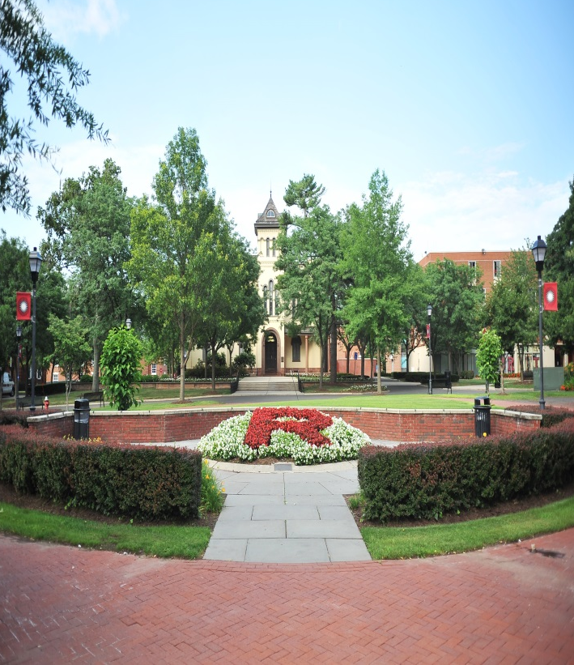
Targum Publishing Company is a non-for-profit organization operating under specific guidelines prescribed by the State of New Jersey and the Internal Revenue Service. The Targum does not have an endowment fund, alumni campaign, or any other form of outside funding typically found at not-for-profit entities.
Currently, the Targum is dependent on revenue from the payment of the Targum fee by students on their Rutgers University term bills. The $11.25 charge on the student’s term bill pays for crucial aspects of our operations such as printing, delivery, and editorial expenses.

The other source of income that supports The Daily Targum is advertising revenue. The state of the economy has contributed to a drastic decrease in print advertising nationwide. Local businesses have struggled to find a place in their budget for advertising at the economy has lagged. As a result, businesses have gravitated towards the use of free resources such as Facebook and Craigslist in order to advertise. Although the Targum is making an active push towards online advertising, we still need time to build up our online presence and still have a long way to go until we are able to sustain ourselves on online advertising alone. While the Targum provides direct access to a unique market and continues to serve a loyal client base, drastic drops in advertising revenue since 2008 have made it clear that the company cannot survive on print advertising revenue alone either. It is with the continued support of Rutgers students that the Targum’s doors remain open.
Since 1980, Targum Publishing Company has conducted referenda on each Rutgers University-New Brunswick campus on a three-year basis in order to secure student approval of the Targum’s status on the term bill. Students may request a refund of the Targum fee if desired. At the beginning of each semester, an official notice regarding the opportunity to obtain a refund is sent out to the student body via e-mail. Information about the refund process is available to students on www.dailytargum.com and the Student Accounting website.

Alumni Testimonials
Rebecca Quick
Editor In Chief 1992-1993

(Anchor of CNBC’s Squawk Box and the syndicated program On the Money)
I love Rutgers. But I often feel like I graduated from The Daily Targum because I spent so much of my student career there, and because what I learned at the Targum is what got me a job after graduation. It’s where I learned to write and communicate, and it’s why I was hired by The Wall Street Journal straight out of school.
Every year, hundreds of students pass through the Targum’s doors. They learn writing, reporting, editing, photography, production, advertising and business skills, not to mention responsibility, professionalism and teamwork. Having a daily newspaper is an incredible on-campus training ground and a real advantage that Rutgers provides to students and prospective students. And it’s a point of pride that Rutgers has the second oldest campus newspaper in the country — founded in 1869, seven years before The Daily Princetonian was founded just down the road.
And then here’s the service that the Targum provides the entire University community. It’s how students and faculty alike learn about campus news and University life. It provides a common thread to bind and inform the community. It’s hard to imagine Rutgers without a daily newspaper. Student funding is key to the Targum’s survival.

Tyler O’Keefe
Marketing Director 2014-15
The Targum has helped me push limits and see what is possible. It gave me the skills I needed to collaborate on ideas, be innovative, and follow through on goals. For me, it was the perfect blend of a future job market. Offering quality work experience for jobs in public relations, project management, business, marketing, journalism, design, and advertising, this cannot be found anywhere else.

Skylar Frederick
Business Manager 2014-15
Working at Targum provided me with a broad range of skills and experience that I use daily. I learned more about my field while working at Targum than I ever could have learned in the classroom. My current job as a social media associate has me constantly acting as a reporter, writer, marketer, editor and brand manager. My time with TPC armed me with the knowledge to be able to succeed in all of these areas.

Christy Morrison
Associate News Editor 2000-01
Business Writer for The Gordian Group in SC.
My time at the Targum was the epitome of ‘the college experience’: It prepared me for my professional future while fulfilling my passion for writing; it allowed me to foster lasting relationships with future leaders in the field of journalism; and it instilled in me a work ethic I value to this day.

Anna Rozin
Marketing Director 2004-05
Attorney at Bracewell & Giuliani
The experience I gained while working at the Targum is evident in my day-to-day life. Every time I am in a position of having to manage others, problem solve on the fly, or coordinate large projects, I am reminded of my time at the Targum, which prepared me for it all.

Kerri Wilson
University Administrative Liason to the B.O.T
Director of Student Involvement, Rutgers
It has been an honor to serve as a resource for the Targum Board and a connection between The Daily Targum and the University administration.

Joshua Cohen
Business Manager 2010-12
Owner/CEO Willowstone Capital Management
My professional experience at Targum helped provide me with many important business skills that I will surely be using throughout my career.

Some Rutgers alumni who called themselves Targumites: Poet Joyce Kilmer, US Senator Clifford Case, CNBC’s Squak Box co-anchor Rebecca Quick, Nobel Prize winner Milton Friedman, television commentator Martin Argonsky, and Nobel Prize winner Selman Waksman.

Conclusion
The Daily Targum is a widely circulated medium throughout the tremendously diverse Rutgers University community. The Newspaper seeks to create a sense of common educational goals among students, faculty, and staff members. It is an informative resource for a number of topics and pressing issues. It is a source of entertainment and culture. It serves to create a dialogue between the students and the university administration. For those students who choose to be directly involved in the daily production of the Targum, the newspaper offers educational and social benefits during their matriculation at Rutgers University as well as countless benefits in their post-graduate endeavors. The Daily Targum has been a part of Rutgers University tradition for more than 150 years and takes great pride in the services it provides to the Rutgers community. It is our hope to continue the Targum legacy at Rutgers and with continued support of student funding, this will be possible.

